Entity-Relationship Document: Real-Time SIEM Log Engine
Oct 18, 2026 · @Jared Furtado

1. ER Diagram
The diagram uses Chen notation: rectangles are entities, diamonds are relationships, and a double line marks total participation. The letters beside each line give cardinality. Attributes are not drawn as ovals because there are about 50 of them; each entity's attributes, with the primary key in bold, are in Section 2.
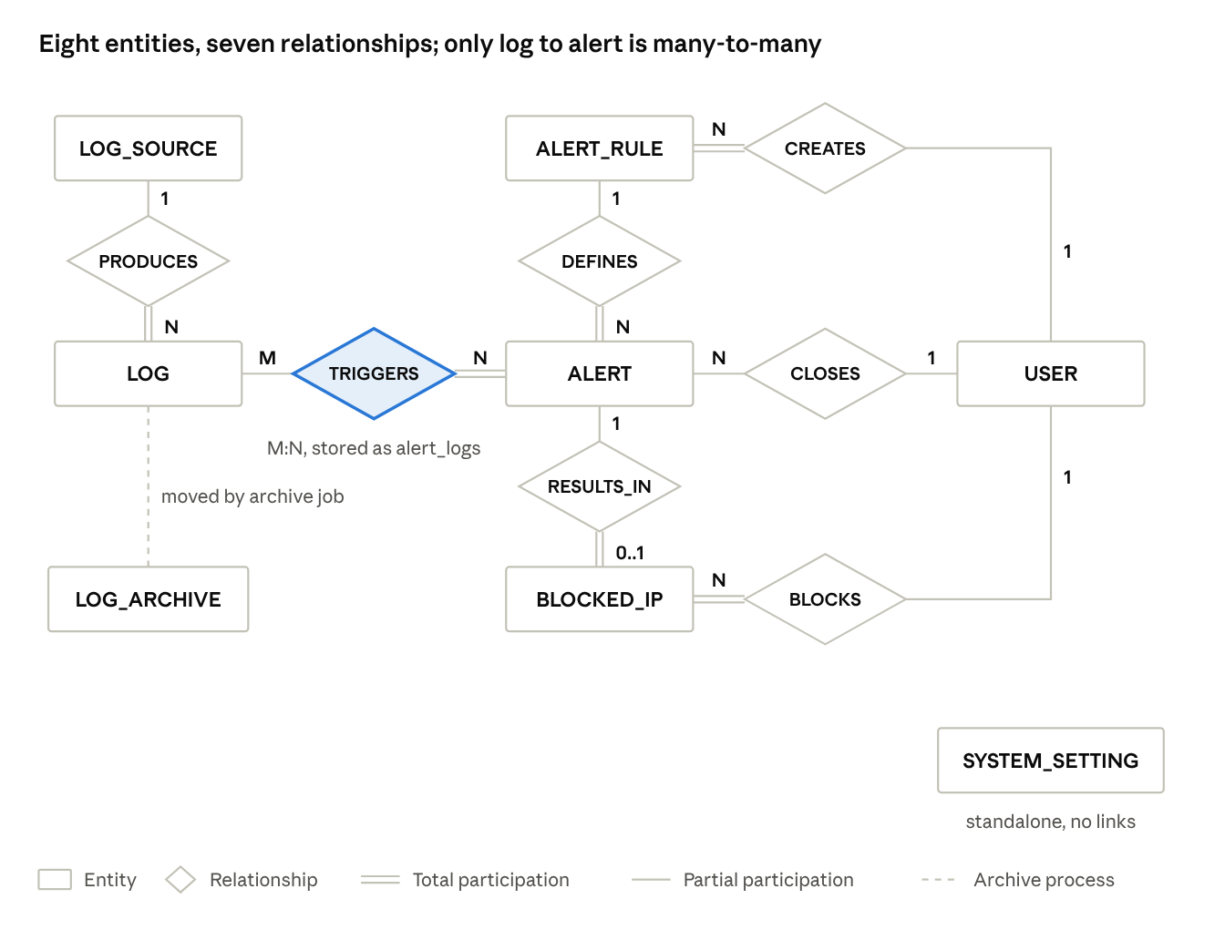
Chen ER diagram · 8 entities, 7 relationships
The only many-to-many link is TRIGGERS: one alert comes from many logs, and one log can trip several rules. It is stored as the alert_logs table. LOG_ARCHIVE has a dashed line only because the archive job moves rows into it, which is a process and not a relationship.

2. Entities and Attributes
The model has eight entities. Primary keys are in bold. Foreign keys are not listed here, because in Chen notation they come from the relationships in Section 3 and appear in the relational schema in Section 4.

2.1 USER
SIEM operators only: Admin, Security Analyst or Viewer. Demo-website visitors are not users of the SIEM.
Attribute | Domain | Description
user_id | Integer (surrogate) | Primary key, auto-generated
username | Varchar(50) | Unique login name
email | Varchar(100) | Unique contact email
password_hash | Varchar(255) | Hashed password, never plain text
role | Enum('admin','analyst','viewer') | Exactly one role per user
is_active | Boolean | False once an Admin deactivates the account
created_at | Timestamptz | Account creation time

2.2 LOG_SOURCE
Where a stream of logs comes from, such as the demo web application.
Attribute | Domain | Description
source_id | Integer (surrogate) | Primary key
source_name | Varchar(100) | For example "demo-web-app"
source_type | Varchar(50) | For example "web" or "auth-service"
api_key_hash | Varchar(255) | Hashed API key the source uses to send events
created_at | Timestamptz | When the source was registered

2.3 LOG
The core fact entity: one row per event. It is partitioned by month on ts, which is why ts is part of the key.
Attribute | Domain | Description
log_id | Bigint (from a sequence) | Primary key component
ts | Timestamptz | Primary key component, event time and partition key
actor_username | Varchar(50), nullable | Username as the source reported it; null for system or anonymous events
src_ip | Inet | Source IP address of the event
event_type | Varchar(50) | For example "login_failed" or "page_view"
status | Integer | HTTP-style result code
user_agent | Text | Browser or client identifier
payload | Text | Raw request text, search term or form input

2.4 ALERT_RULE
An Admin-defined rule that detects suspicious activity. A rule is either a threshold or a pattern, so each type has its own columns.
Attribute | Domain | Description
rule_id | Integer (surrogate) | Primary key
rule_name | Varchar(100) | Human-readable name
rule_type | Enum('threshold','pattern') | Which kind of rule this is
event_type | Varchar(50), nullable | Event counted by a threshold rule
threshold_count | Integer, nullable | Count that triggers a threshold rule
pattern | Text, nullable | Regex matched against payload by a pattern rule
window_seconds | Integer | Time window the rule is evaluated over
severity | Enum('low','medium','high') | Severity given to alerts from this rule
enabled | Boolean | Whether the scheduler evaluates the rule

2.5 ALERT
One firing of a rule against a source IP.
Attribute | Domain | Description
alert_id | Integer (surrogate) | Primary key
src_ip | Inet | The IP the alert is about
status | Enum('open','closed') | Lifecycle state
raised_at | Timestamptz | When the alert was generated
closed_at | Timestamptz, nullable | When an analyst closed it
closing_note | Text, nullable | Investigation outcome

2.6 BLOCKED_IP
An IP address blocked after an analyst confirmed an alert.
Attribute | Domain | Description
block_id | Integer (surrogate) | Primary key
ip_address | Inet | The blocked IP, equal to the alert's src_ip
blocked_at | Timestamptz | When the block was made
unblocked_at | Timestamptz, nullable | Set when the block is lifted

2.7 SYSTEM_SETTING
Configuration values such as retention_months and partitions_ahead. It has no relationships.
Attribute | Domain | Description
setting_key | Varchar(50) | Primary key
setting_value | Varchar(100) | The configured value

2.8 LOG_ARCHIVE
Storage for rows from archived partitions. It has the same attributes as LOG, plus one more.
Attribute | Domain | Description
log_id, ts | As in LOG | Composite primary key, copied unchanged from LOG
(all other LOG attributes) | As in LOG | Copied unchanged
archived_at | Timestamptz | When the row was moved to the archive

3. Relationships
Cardinality counts how many of one entity attach to one instance of the other. Participation is total when every instance must take part (a double line in the diagram) and partial when it may not.
Relationship | Entities | Cardinality | Participation | Meaning
PRODUCES | LOG_SOURCE, LOG | 1 : N | Source partial, log total | Every log comes from exactly one registered source. A source may exist before it has produced any logs.
DEFINES | ALERT_RULE, ALERT | 1 : N | Rule partial, alert total | A rule can fire many times. Every alert comes from exactly one rule.
TRIGGERS | LOG, ALERT | M : N | Log partial, alert total | An alert is raised from at least one log (a brute-force alert from many), and one log can contribute to alerts from several rules. Most logs trigger nothing.
RESULTS_IN | ALERT, BLOCKED_IP | 1 : 0..1 | Alert partial, blocked IP total | An alert may or may not lead to a block. Every block record belongs to the alert that caused it.
CLOSES | USER, ALERT | 1 : N | Both partial | An analyst can close many alerts. Not every alert has been closed yet.
BLOCKS | USER, BLOCKED_IP | 1 : N | User partial, blocked IP total | An analyst can block many IPs. Every block was made by a user.
CREATES | USER, ALERT_RULE | 1 : N | User partial, rule total | An Admin can create many rules. Every rule has a creator.
Three modelling decisions explain what is missing from this table:
- No USER to LOG relationship. Logs record the username as the source reported it, because logs from other sources have no SIEM user, and a log should not depend on another system's accounts.
- No relationship carries its own attributes. Details such as when an alert was closed are attributes of ALERT.
- Archiving is not a relationship. Moving old partitions into LOG_ARCHIVE is a storage process, not a link between independent entities. SYSTEM_SETTING is a standalone configuration entity.

4. Relational Schema (Derived from the ER Diagram)

4.1 Mapping rules applied
- Each entity becomes a table and each attribute a column, with the key attribute(s) as the primary key.
- For every 1:N relationship, a foreign key goes on the "many" side. Total participation makes it NOT NULL; partial participation makes it nullable (for example alerts.closed_by).
- The 1:0..1 relationship RESULTS_IN puts the foreign key on blocked_ips, the total side, and makes it UNIQUE so an alert has at most one block.
- The M:N relationship TRIGGERS becomes a new table, alert_logs, whose key is the combination of both sides.
- logs uses the composite key (log_id, ts) because PostgreSQL requires the partition column in every unique constraint of a partitioned table. This is a physical requirement, not a conceptual one.

4.2 Schema
A dagger (†) marks a foreign key.
Table | Primary key | Other columns
users | user_id | username, email, password_hash, role, is_active, created_at
log_sources | source_id | source_name, source_type, api_key_hash, created_at
logs | (log_id, ts) | source_id†, actor_username, src_ip, event_type, status, user_agent, payload
alert_rules | rule_id | rule_name, rule_type, event_type, threshold_count, pattern, window_seconds, severity, enabled, created_by†
alerts | alert_id | rule_id†, src_ip, status, raised_at, closed_at, closing_note, closed_by†
alert_logs | (alert_id, log_id, ts) | none (alert_id† is a foreign key)
blocked_ips | block_id | alert_id† (unique), ip_address, blocked_at, unblocked_at, blocked_by†
system_settings | setting_key | setting_value
logs_archive | (log_id, ts) | same columns as logs, plus archived_at

4.3 Foreign keys
Foreign key | References | Nullable
logs.source_id | log_sources.source_id | No
alert_rules.created_by | users.user_id | No
alerts.rule_id | alert_rules.rule_id | No
alerts.closed_by | users.user_id | Yes, until the alert is closed
alert_logs.alert_id | alerts.alert_id | No
blocked_ips.alert_id | alerts.alert_id | No, unique
blocked_ips.blocked_by | users.user_id | No
alert_logs (log_id, ts) deliberately has no foreign key to logs. Partitions are detached and archived, and a foreign key would block that. The archive job only moves rows, so evidence lookups check logs first and then logs_archive.

4.4 Relational diagram
Each box is a table. Arrows run from a foreign key to the table it references.
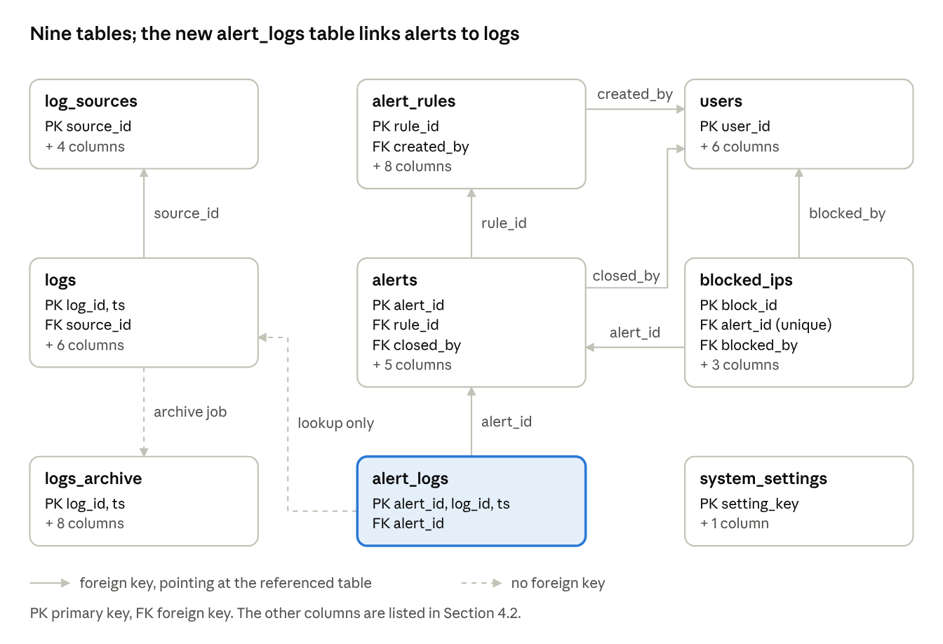
relational diagram · 9 tables, 7 foreign keys
The two dashed lines are not foreign keys. alert_logs (log_id, ts) is a lookup into logs or logs_archive, and the archive job copies rows from logs into logs_archive.

4.5 Key constraints in SQL
CREATE SEQUENCE logs_log_id_seq;
CREATE TABLE logs (
log_id bigint NOT NULL DEFAULT nextval('logs_log_id_seq'),
ts timestamptz NOT NULL,
source_id integer NOT NULL REFERENCES log_sources (source_id),
actor_username varchar(50),
src_ip inet NOT NULL,
event_type varchar(50) NOT NULL,
status integer,
user_agent text,
payload text,
PRIMARY KEY (log_id, ts)
) PARTITION BY RANGE (ts);
CREATE TABLE alert_logs (
alert_id integer NOT NULL REFERENCES alerts (alert_id),
log_id bigint NOT NULL,
ts timestamptz NOT NULL,
PRIMARY KEY (alert_id, log_id, ts)
);
-- at most one open alert per rule and IP
CREATE UNIQUE INDEX one_open_alert
ON alerts (rule_id, src_ip) WHERE status = 'open';
-- at most one active block per IP
CREATE UNIQUE INDEX one_active_block
ON blocked_ips (ip_address) WHERE unblocked_at IS NULL;

5. Functional Dependencies
A functional dependency X → Y means that a value of X determines the value of Y. Every table below is in BCNF except alert_logs, which has one deliberate exception explained in 5.3.

5.1 Dependencies per relation
Relation | Functional dependencies
users | user_id → all other columns. username → all columns and email → all columns, since both are unique.
log_sources | source_id → source_name, source_type, api_key_hash, created_at
logs | log_id → ts, source_id, actor_username, src_ip, event_type, status, user_agent, payload
alert_rules | rule_id → rule_name, rule_type, event_type, threshold_count, pattern, window_seconds, severity, enabled, created_by
alerts | alert_id → rule_id, src_ip, status, raised_at, closed_at, closing_note, closed_by
blocked_ips | block_id → alert_id, ip_address, blocked_at, unblocked_at, blocked_by. alert_id → all columns, since it is unique.
system_settings | setting_key → setting_value
logs_archive | log_id → all other columns, as in logs

5.2 Normal form summary
Relation | Highest normal form | Why
users | BCNF | Every determinant (user_id, username, email) is a candidate key.
log_sources | BCNF | Single-column key, no other determinants.
logs | BCNF | log_id is the key. ts is part of the physical primary key only for partitioning.
alert_rules | BCNF | Single-column key. Type-specific columns are nullable but add no dependencies.
alerts | BCNF | Single-column key. The old log reference and its copied columns are gone, so no transitive dependency remains.
alert_logs | 1NF, with one deliberate exception | See 5.3.
blocked_ips | BCNF | block_id and alert_id are both candidate keys.
system_settings | BCNF | Single-column key.
logs_archive | BCNF | Same structure as logs.

5.3 The alert_logs exception
Because log_id determines ts, the minimal key of alert_logs is (alert_id, log_id), and ts depends on only part of it. Strictly, that breaks 2NF. The copy of ts is kept on purpose: it lets a lookup use the full key of logs and go straight to the right partition.
If strict 2NF is required, drop ts from alert_logs and add a plain index on logs (log_id). The cost is that evidence lookups then search every partition. State this trade-off if asked.

5.4 Note on the logs key
log_id comes from a sequence, so it is unique in practice and determines every other column. PostgreSQL, however, can only enforce uniqueness of the pair (log_id, ts) on a partitioned table. In strict terms (log_id, ts) is a superkey, and log_id is the true determinant.

6. Changes from the Previous ER Document
Previous version | This version | Why
LOG TRIGGERS ALERT as 1:1 | M:N, stored in alert_logs | A brute-force alert comes from many logs, and one log can trip several rules.
alerts held log_id, ts and a copy of the log's IP | alerts keeps only its own src_ip | The copies created a transitive dependency, so the old 3NF claim was false.
DEMO_ACTION entity | Removed | Every demo action already becomes a LOG row. Demo-site data lives in a separate demo schema.
USER GENERATES LOG, with an end_user role | Removed; LOG has actor_username | Demo visitors are not SIEM users, and a log should not depend on another system's accounts.
One pattern_or_threshold column | rule_type, event_type, threshold_count, pattern | One text column holding a number or a regex is not atomic.
Missing attributes | Added enabled, closed_at, closing_note, is_active, unblocked_at, api_key_hash | The requirements need them.
No home for retention or archive | Added SYSTEM_SETTING and LOG_ARCHIVE | Retention is configurable and archiving is required.
Cardinality drawn but participation only in a table | Participation shown in the diagram as double (total) and single (partial) lines | The diagram now carries the full constraint.
Archive Record in requirements but not in the schema | logs_archive added to the schema | The two documents now agree.

